CAG Devon How-to Guide:

Income Diversification: Balancing People, Profit and Planet

Kindly created by Alison Sallis from Proper Job

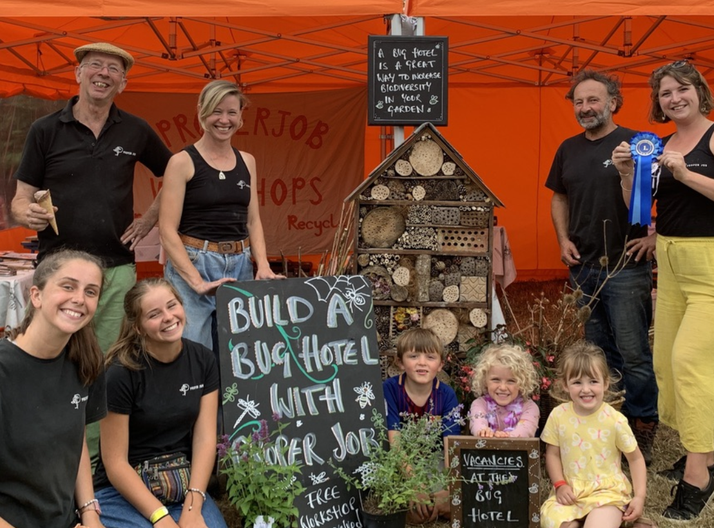

Table of Contents
Kindly created by Alison Sallis from Proper Job 1
Table of Contents 2
About the author 5
Toolkit Purpose 6
The toolkit focuses on: 6
Understanding your Stakeholders and Community Needs 7
Stakeholder Mapping 7
Purpose 7
Activity: Mapping your stakeholders 7
Step 1: Identify stakeholders 8
Step 2: Map stakeholders using a Power/Interest grid 8
Step 3: Use the map to guide engagement 9
Output 9
Key insight 9
Stakeholder List – Example ideas to get your CAG group started 9
Group Visioning Session 11
Purpose 11
Activity: Future Vision Exercise 11
Step 1: Future vision (5 years ahead) 11
Step 2: Values and boundaries 11
Step 3: Defining success 11
Step 4: Income and independence 12
Outputs 12
Key insight 12
Community Survey Toolkit 13
Purpose 13
When to use it 13
Step 1: Start with your goal (work backwards) 13
Step 2: Choose your method (not just surveys) 13
Step 3: Reach the right people 13
Step 4: Design good questions 14
Step 5: Test your survey 14
Step 6: Share and collect responses 15
Step 7: Review and use your findings 15
Output 16
AI Tools 16
Exploring new income opportunities aligned with your values 17
SWOT Analysis 18
Purpose 18
Framework 18
Income-Focused Questions 19
Output 19
Key insight 19
PESTLE Analysis 20
Purpose 20
Framework 20
Key Questions 22
Output 22
Key insight 22
Case Study 22
Opportunities Identified 24
Risks Identified 25
Ansoff Matrix (Income Diversification) 26
Framework 27
Discussion Prompts 27
Output 27
Key insight 28
Developing and testing income ideas 29
Offer Canvas 29
Purpose 29
Offer Canvas Questions 30
Key prompts 30
Output 30
Key insight 30
Pricing for Purpose 31
Purpose 31
People, Planet, Profit Framework 33
Making pricing more accessible 33
Key prompts 33
Output 34
Key insight 34
Pilot Planning Canvas 35
Purpose 35
Key ideas behind the tool 36
Output 36
Key insight 36
Impact vs Effort Matrix 37
Purpose 37
Framework 37
How to use it 38
Key prompts 38
Output 38
Key insight 38
Financial planning for sustainability 39
Integrated Financial Planning, Budgeting & Sustainability Tool 39
Purpose 39
Step 1: Bring together your planning evidence 39
Step 2: Design and test activity viability 40
Step 3: Build your activity-based budget 40
Step 4: Map income across the year 41
Step 5: Agree the budget as a group 41
Step 6: Use tools and systems to manage finances 41
Step 7: Monitor, review, and adapt 41
Step 8: Use your budget strategically 41
Outputs 42
Key insight 42

About the author

Alison Salis is the CEO of Proper Job Resource Centre, an environmental charity based in Devon with a mission to reduce waste and promote practical, community-led sustainability.

Proper Job operates a large community reuse centre where donated items are diverted from landfill and resold to support environmental action. Income generated through this work funds a wide range of initiatives, including repair cafés, educational workshops, sustainability events, film screenings, and hands-on community activities.
Alison has worked with Proper Job for over 12 years and is currently CEO. She founded the organisation as a charity in 2017, building on its original establishment in 1995. Since then, she has led the development of a diversified and resilient income model that enables the organisation to grow its impact while remaining firmly rooted in its environmental mission.
Under her leadership, income diversification has included expanding retail outlets and developing new shops, e-commerce sales, fundraising events, a community lottery, grant funding, local authority contracts, corporate sponsorship, Gift Aid, and money-saving community projects. Alongside trading and fundraising, income is also generated through repair cafés and workshops, strengthening both financial sustainability and community engagement.
The organisation has also developed sustainability-focused investment and funding approaches, including support for solar energy installation, grant-funded environmental infrastructure, social investment, and income from skills-based workshops.
Proper Job now employs seven full-time equivalent local staff and is supported by a strong volunteer workforce, reflecting its commitment to community ownership and participation.
Alison is a Fellow of the School for Social Entrepreneurs and has completed its Start Up, Trade Up, and Scale Up programmes. She has also worked as a coach and mentor with the School for Social Entrepreneurs, supporting other organisations to develop sustainable, mission-led strategies.
In addition, Alison has recently completed an MBA in Senior Leadership with Arden University, strengthening her expertise in financial sustainability, organisational development, and strategic leadership within the charity and social enterprise sector.

Toolkit Purpose
This toolkit is designed to support members of Community Action Groups (CAGs) working to protect and improve the environment to think strategically about diversifying their income.
Community groups come in many different forms, from tool libraries and repair cafés to tree planting initiatives, community climate action projects, and local sharing schemes. While many are largely volunteer-led, most still face essential overheads such as space rental, insurance, utilities, and equipment costs. To remain sustainable, groups often need to generate income alongside delivering their core activities.
There are many ways that CAGs raise income, including trading, delivering services, fundraising initiatives and securing grant funding. This toolkit aims to help groups explore and develop these opportunities so they can better support the long-term sustainability of their work.
The toolkit provides practical frameworks, exercises, and prompts that can be used during group visioning sessions, planning days, or board workshops. While the tools can be used individually, they are most effective when completed as a group. Working collaboratively brings a broader range of perspectives, strengthens shared understanding, and helps build collective ownership of ideas. This early involvement increases buy-in and improves the likelihood that new initiatives will be successfully implemented.

The toolkit focuses on:
- Understanding your stakeholders and community needs
  - Stakeholder mapping exercises
  - Community surveys and engagement approaches
  - Group visioning session ideas, clarifying your mission, values, and organisational strengths
  - Basic market analysis tools
- Exploring new income opportunities aligned with your values
  - SWOT analysis
  - PESTLE analysis
  - Ansoff Matrix
  - Income diversification strategies
- Developing and testing income ideas
  - Offer Canvas
  - Pricing for Purpose
  - Pilot Planning Canvas
  - Impact vs Effort Matrix
- Financial planning for sustainability
  - Budgeting and forecasting
  - Monitoring and reviewing financial performance against budget
  - Testing viability and adjusting plans to respond to changes in income, costs, and external conditions
  - Integrated Financial Planning, Budgeting & Sustainability

Understanding your Stakeholders and Community Needs
Before developing new income ideas, it’s important to understand who influences your work and what your community needs. This helps ensure that any income diversification is relevant, supported, and aligned with your mission.
Different stakeholders—such as community members, partners, funders, and local organisations—play different roles in your work and have varying levels of influence and interest. At the same time, community insight is essential for identifying real needs and opportunities.
This section introduces three practical tools to support this process: stakeholder mapping, group visioning, and a community survey toolkit. Together, they help you build a clear picture of who to engage, what matters to your community, and how to align future income activities with your purpose and values.

Stakeholder Mapping

Purpose
To identify who has influence over, interest in, or is impacted by your work, and to understand who may support or influence income diversification.
This helps you prioritise engagement and ensure the right people are involved in decisions.

Activity: Mapping your stakeholders
Start by listing all stakeholders connected to your organisation. These may include individuals, groups, or organisations such as:
- Community members
- Volunteers
- Local residents
- Partner organisations
- Local authorities
- Funders
- Service users
- Local businesses

Step 1: Identify stakeholders
Create a full list of everyone who:
- Supports your work
- Is affected by your work
- Has influence over your work
- May benefit from or challenge your income ideas

Step 2: Map stakeholders using a Power/Interest grid
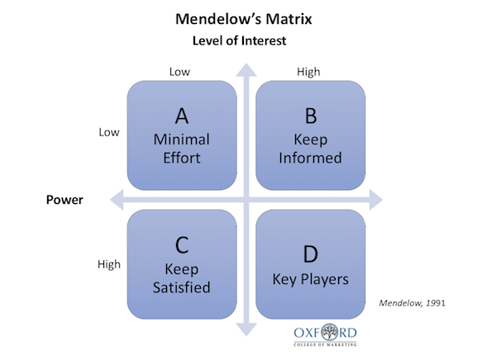
The Power/Interest Grid is based on the work of Mendelow (1991), which helps organisations understand which stakeholders to involve closely and which to simply monitor or keep informed, depending on their level of influence and interest.
Place each stakeholder into one of the following four categories:
High Power / High Interest
Key stakeholders who should be closely involved and engaged regularly
High Power / Low Interest
Stakeholders who have influence but may not be actively engaged day-to-day. Keep satisfied and informed where needed
Low Power / High Interest
Stakeholders who are highly affected or interested. Keep informed and involved where possible
Low Power / Low Interest
Stakeholders with limited influence or interest. Monitor with minimal effort

Step 3: Use the map to guide engagement
Once mapped, consider:
- Who should be involved in shaping income ideas?
- Who needs regular updates or communication?
- Who could support or block new income activities?
- Who is currently missing from conversations?

Output
By the end of this exercise, you should have:
- A clear list of your key stakeholders
- A visual Power / Interest map
- A better understanding of who to engage, involve, inform, or monitor
- Insight into who may support or influence income diversification

Key insight
Not all stakeholders need the same level of attention. This tool helps you focus your time and energy where it will have the greatest impact, especially when developing new income activities.

Stakeholder List – Example ideas to get your CAG group started
Community Stakeholders
- Local residents
- Volunteers
- Community members
- Young people and schools
- Community groups and associations
- Allotment holders
- Recreational users (walkers, cyclists, anglers)
Landowners and Businesses
- Local farmers
- Landowners
- Local businesses
- Tourism businesses
- Renewable energy providers
- Developers and construction companies
Public Sector
- Parish Council
- Town Council
- District/Borough Council
- County Council
- Local authority environmental officers
- Elected councillors
- MPs
Partner Organisations
- Other CAG Groups
- Wildlife trusts
- Rivers trusts
- Environmental charities
- Community foundations
- National park authorities (where applicable)
- Academic institutions and researchers
Funders and Supporters
- Grant funders
- Corporate sponsors
- Local philanthropists
- Lottery funders

Group Visioning Session

Purpose
To develop a shared understanding of your organisation’s future direction, and how income diversification can support and strengthen your mission.
This session helps groups align around a common vision before making decisions about new income-generating activities.

Activity: Future Vision Exercise
Begin by selecting participants informed by your stakeholder mapping. Aim for a balanced mix of voices from within your organisation and, where appropriate, key community stakeholders.
Invite them to take part in a facilitated group session or focus group. Explain that the purpose is not to plan immediate actions, but to imagine the future of the organisation and what success looks like over the longer term.

Step 1: Future vision (5 years ahead)
Ask participants to imagine your organisation five years from now and discuss:
- What impact are we having on the environment?
- Who are we working with?
- What does financial sustainability look like for us?
- Where does our income come from?
Encourage participants to think beyond current limitations and consider what is possible, not just what is realistic today.

Step 2: Values and boundaries
Discuss the principles that should guide your organisation’s decisions.
Prompts:
- What do we never want to compromise on?
- What are our core values as an organisation?
- What ethical limits should guide how we generate income?

Step 3: Defining success
Explore what success looks like from a community perspective:
- What would success look like for our community?
- How will we know we are making a positive difference?
- What does meaningful impact look like in practice?

Step 4: Income and independence
Link the vision to financial sustainability:
- How could diversified income strengthen our independence?
- What kinds of income sources feel aligned with our values?
- What should we avoid relying on too heavily?

Outputs
By the end of the session, you should have:
- A shared vision statement (what the future looks like)
- A clearer sense of your mission (how you will get there)
- A set of agreed values and ethical principles guiding decision-making
- Early ideas about how diversified income supports your long-term sustainability

Key insight
Strong income strategies are much easier to design when they are grounded in a clear shared vision. This session helps ensure that financial decisions support your mission, rather than drift away from it.

Community Survey Toolkit

Purpose
To help your group gather useful insights from your community so you can design activities, services, or income ideas that people actually need and value.

When to use it
- When exploring new income opportunities
- Before launching a new service or activity
- When you need evidence to support funding or decision-making
- When you want to better understand your community

Step 1: Start with your goal (work backwards)
Before writing any questions, be clear on:
TOP TIP
If you don’t know how you’ll use the answers, don’t ask the question.

What do we want to find out?
What decisions will this information help us make?
Example:
“Would people pay for this service?”
“What kind of repair workshops are most needed?”
“When are people available to attend?”

Step 2: Choose your method (not just surveys)
Surveys are useful—but they’re not the only option. You can gather insights through:
- Online surveys (e.g. Google Forms, Microsoft Forms, SurveyMonkey)
- Paper surveys (events, community spaces)
- Street conversations / informal interviews
- Focus groups
- Attending existing community sessions
- Existing data / research

The best approach is often a mix of methods.

Step 3: Reach the right people
Think carefully about who you want to hear from. Key questions:
- Who is this for? (be specific)
- Who might be missing if we only use one method?
- How can we reach different groups?

Examples:
TOP TIP
If you only share your survey online, you will miss some groups.

Older residents → paper surveys, community centres, local newsletters
Young people → social media, schools, youth groups
General public → events, high street conversations

Step 4: Design good questions
Aim for a mix of quantitative (numbers) and qualitative (opinions) questions.
Types of questions to include:
1. Closed questions (quantitative)
- Multiple choice
- Rating scales
- Yes/No
Good for identifying patterns and trends

2. Open questions (qualitative)
- “What would you like to see more of in your community?”
- “What would stop you from taking part?”
Good for deeper insight and new ideas

Avoid common mistakes:
- Leading questions
For example, rather than asking “How much do you like our great idea?” ask “How interested would you be in this idea?”
- Asking too many questions
Keep it short and focused—aim for a survey that takes 5–10 minutes maximum.
- Asking vague questions
For example, instead of “Would you attend events?” ask “Would you attend a weekend repair workshop?”

Step 5: Test your survey
Before sharing widely:
- Test it with 2–3 people
- Check questions are clear
- Check it takes a reasonable amount of time
- Fix anything confusing

Step 6: Share and collect responses
Use a mix of channels:
- Online (email, social media, website)
- In-person (events, community spaces, street outreach)
- Through partners (schools, councils, local groups)

Top tip
Be clear about:
- Why you’re asking
- How long it will take
- How the information will be used

Step 7: Review and use your findings
Once responses are collected:
Look for:
- Common themes
- Patterns in responses
- Surprising insights
- Differences between groups

Then ask:
- What does this mean for our ideas?
- What should we do differently?
- What opportunities does this highlight?
- Data handling and personal information
- Only collect personal data if you genuinely need it for your purpose
- Avoid asking for unnecessary details such as full names, addresses, or contact information
- If you do collect personal data, be clear about:
- why you are collecting it
- how it will be used
- how it will be stored and protected
- Keep data collection to the minimum needed to achieve your aims
- Consider offering surveys anonymously wherever possible

Output
By the end of this process, you should have:

- A clearer understanding of your community’s needs
- Evidence to support decisions or funding applications
- Insight into what people value and might pay for
- Better confidence in your next steps

AI Tools
AI can help identify patterns in large numbers of open-text responses.
Examples include:
- Grouping similar comments together
- Identifying common themes
- Highlighting frequently mentioned issues
- Summarising feedback from different groups
- Spotting unexpected insights
Example prompt:
"Here are 100 survey responses. Please identify the main themes, estimate how frequently each theme appears, and highlight any significant differences between young people, families, and older residents."
AI can save significant time, but outputs should always be reviewed by a person to ensure important nuances are not missed.

Exploring new income opportunities aligned with your values
Developing new income opportunities is most effective when it is grounded in a clear understanding of your organisation’s strengths, the needs of your community, and the wider environment you operate in. This section provides a structured set of tools to help you move from ideas to practical, realistic and values-led income generation.
Together, these tools support a step-by-step approach to income diversification—from analysing your internal and external context, to generating ideas, testing viability, and prioritising what to develop.
The aim is not just to increase income, but to ensure that any new opportunities are aligned with your mission, financially sustainable, and achievable within your capacity.
These tools will help you:
- Understand your strategic position (SWOT, PESTLE, Ansoff Matrix)
- Generate and shape income ideas (Offer Canvas, Pricing for Purpose)
- Test viability and reduce risk (Pilot Planning Canvas, Impact vs Effort Matrix)
- Prioritise the most realistic and valuable opportunities
By working through these stages, you can build a more confident, evidence-based approach to income diversification that balances people, planet, and financial sustainability.
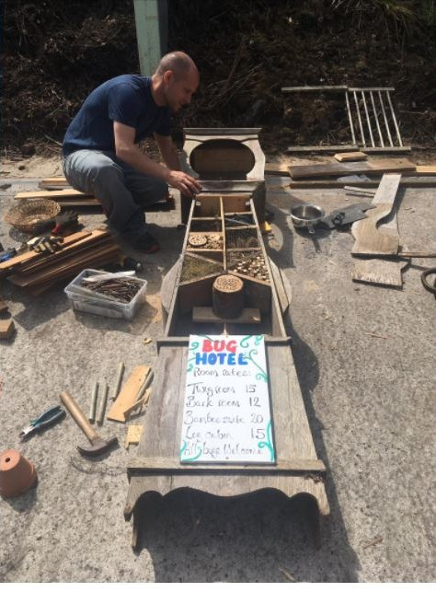

SWOT Analysis
Purpose
To understand your organisation’s internal strengths and weaknesses alongside external opportunities and threats. This works best as a group exercise, as it brings together different perspectives and builds shared understanding of what is realistically possible.

Framework
Work through each area as a group and record ideas on a flipchart or worksheet.
Strengths  - What we do well?  - What resources, skills, or relationships do we already have?  Examples might include:  - Strong community trust  - Skilled volunteers  - Access to space or equipment  - Local partnerships  - Experience delivering activities | Weaknesses  Where do we struggle?  What limits our effectiveness or growth?  Examples might include:  - Limited time or capacity  - Lack of financial systems or planning  - Reliance on a small number of volunteers  - Gaps in skills (e.g. marketing, finance)  - Limited funding stability
Opportunities  - What is happening outside the organisation that we could benefit from?  Examples might include:  - New funding streams or grants  - Growing demand for environmental action  - Partnerships with schools, councils, or businesses  - Local policy priorities (climate, wellbeing, community resilience)  - Public interest in sustainability and reuse | Threats  - What external factors could negatively affect our work?  Examples might include:  - Changes in funding priorities or policy  - Increased competition for grants or contracts  - Rising costs (rent, utilities, insurance)  - Volunteer burnout or declining engagement  - Climate or environmental risks affecting delivery

Income-Focused Questions
Use these prompts to connect SWOT thinking directly to income diversification:
- Which of our strengths could directly generate income?
- What weaknesses are holding us back from developing new income streams?
- What external trends could create new income opportunities?
- What financial risks do we need to plan for before diversifying income?
- Where could partnerships help us turn opportunities into income?

Output
By the end of the exercise, you should have:
- A clear, shared SWOT analysis
- A shortlist of key strategic insights
- Identification of strengths that could support income generation
- Awareness of barriers that may need investment or support
- A clearer sense of realistic opportunities for diversification

Key insight
SWOT is most valuable when it is honest and realistic. The goal is not to create a perfect picture, but to understand where your organisation is strong enough to act, and where you may need support before expanding income activity.

PESTLE Analysis

Purpose
To understand the wider external environment that may influence your organisation’s ability to diversify income. This helps identify both opportunities and risks outside your direct control.
This tool works best as a group discussion, allowing different perspectives to shape a fuller understanding of external factors.

Framework
Work through each area and consider how it may affect your organisation now and in the future.

Political | Government policy, funding priorities, local and national regulation  - Are there changes in public funding priorities?  - Are there new strategies supporting climate or community action?
Economic | Cost of living, funding availability, local economy  - How are rising costs affecting us or our users?  - Is funding becoming more or less competitive?  - Are there new local economic opportunities?
Social | Community needs, behaviours, and public attitudes  - What are local community priorities right now?  - Is public interest in environmental action increasing or changing?  - Are there underserved groups we could support?
Technological | Digital tools, platforms, and innovation  - Could online platforms help us reach new audiences?  - Are there new tools for fundraising, booking, or service delivery?  - How digitally accessible are our current services?
Legal | Charity law, trading regulations, compliance requirements  - Are we aware of restrictions around trading or income generation?  - Do we need to review our governance or legal structure?  - Are there new compliance requirements we should plan for?
Environmental | Climate change, biodiversity, and environmental pressures  - How are environmental changes affecting our work?  - Are there emerging environmental priorities we could respond to?  - Could climate action create new funding or income opportunities?

Key Questions
Use these to guide discussion:
- What external changes could affect our income generation plans?
- Where are new opportunities emerging (funding, partnerships, demand)?
- What risks or changes do we need to monitor over time?
- How might external trends influence our long-term sustainability?

Output
By the end of the exercise, you should have:
- A list of key external drivers affecting your organisation
- A clearer understanding of emerging opportunities
- Identification of external risks to monitor
- Simple risks and opportunities log to inform planning

Key insight
PESTLE is not a one-off exercise. External conditions change regularly, so revisiting this tool helps ensure your income diversification strategy stays relevant and responsive.

Case Study
A community action group could typically undertake a PESTLE analysis before making significant decisions about future activities, income generation, growth, or organisational planning. It is particularly useful when the group wants to understand whether external conditions are creating new opportunities or risks.

Example PESTLE Analysis: Community Environmental Action Group
Factor | What They Identify | Potential Impact on Income Diversification
Political | Government funding is available for nature recovery, biodiversity enhancement, community climate action, energy efficiency, and environmental education projects. Local authorities may also have sustainability priorities and community grants. Changes in government policy or spending priorities could affect future funding availability. | Opportunities to secure grants, contracts, or sponsorship aligned with government priorities. However, reliance on public funding can create vulnerability if priorities change.
Economic | Rising costs of living are affecting households, reducing disposable income available for donations, memberships, and paid activities. Businesses face increased employment and operating costs, which may reduce sponsorship or charitable giving. Inflation increases the organisation's own running costs. | Reduced income from fundraising, events, and sales. Greater competition for grants and sponsorship. However, organisations may be able to access funding programmes designed to support communities facing economic hardship.
Social | Public concern about climate change, biodiversity loss, flooding, food security, and environmental sustainability is increasing. Communities are seeking practical ways to get involved locally. At the same time, people may have less free time due to work pressures, caring responsibilities, or financial pressures. | Growing demand for environmental education, volunteering opportunities, and community action projects. However, volunteer recruitment and retention may become more challenging.
Technological | Online booking platforms, digital payment systems, crowdfunding platforms, and CRM systems make it easier to manage events and generate income. Social media provides cost-effective ways to reach new audiences and build support. AI tools can assist with grant applications, communications, planning, and administration. | Opportunities to reach wider audiences, reduce administrative costs, improve fundraising efficiency, and develop online services or training programmes.
Legal | Any income-generating activities must comply with charity law (where applicable), trading regulations, safeguarding requirements, insurance obligations, health and safety legislation, employment law, and data protection requirements. New legal requirements may emerge over time. | Additional compliance requirements may increase costs or require specialist advice. Failure to comply could create reputational, financial, or legal risks.
Environmental | Increased awareness of climate change and environmental issues is creating demand for nature-based solutions, biodiversity projects, habitat restoration, and environmental education. However, extreme weather events such as storms, flooding, heatwaves, and prolonged wet periods can disrupt outdoor activities and projects. | New opportunities for funding and service delivery linked to climate adaptation and nature recovery. However, outdoor events and projects may become less predictable and require contingency planning.

Opportunities Identified
Funding and Sponsorship
- Government funding linked to biodiversity, climate action, nature recovery, and environmental education.
- Corporate sponsorship opportunities through Environmental, Social and Governance (ESG) programmes.
- Partnerships with local businesses seeking to demonstrate environmental responsibility.
- Funding programmes designed to support communities affected by the cost-of-living crisis.
Earned Income
- Paid environmental education programmes for schools and youth groups.
- Corporate volunteering days with participation fees.
- Consultancy or advisory services for local organisations on biodiversity and sustainability.
- Workshops on gardening for wildlife, composting, energy saving, or climate resilience.
- Membership schemes and supporter programmes.
Partnerships
- Collaborating with local authorities on environmental projects.
- Working with housing associations, schools, or businesses to deliver funded activities.
- Joint funding applications with other community or environmental organisations.
Digital Opportunities
- Online training and webinars.
- Online fundraising campaigns.
- Use of AI and digital tools to improve efficiency and reduce administration costs.

Risks Identified
Financial Risks
- Reduced household spending affecting event attendance, workshop bookings, memberships, and donations.
- Businesses reducing sponsorship budgets due to economic pressures.
- Rising costs for equipment, insurance, transport, venue hire, and utilities.
Funding Risks
- Increased competition for environmental and community grants.
- Short-term funding cycles creating uncertainty.
- Dependence on a small number of funding sources.
Operational Risks
- Fewer volunteers available because people are working longer hours or have increased caring responsibilities.
- Volunteer burnout if a small number of people take on too much responsibility.
- Difficulty recruiting volunteers with specialist skills.
Legal and Compliance Risks
- Increased requirements relating to health and safety, safeguarding, insurance, data protection, and employment regulations.
- Additional responsibilities if commercial activities are expanded.
Environmental Risks
- Extreme weather causing cancellation of events or delays to projects.
- Climate-related damage to community assets or project sites.
- Seasonal unpredictability affecting outdoor activities and visitor numbers.

Ansoff Matrix (Income Diversification)
Purpose
To explore different income and growth options based on levels of risk and familiarity. This helps groups consider both safer income improvements and more ambitious diversification opportunities.
The Ansoff Matrix, developed by Igor Ansoff, is a strategic planning tool used to identify growth strategies by considering existing and new products and markets.
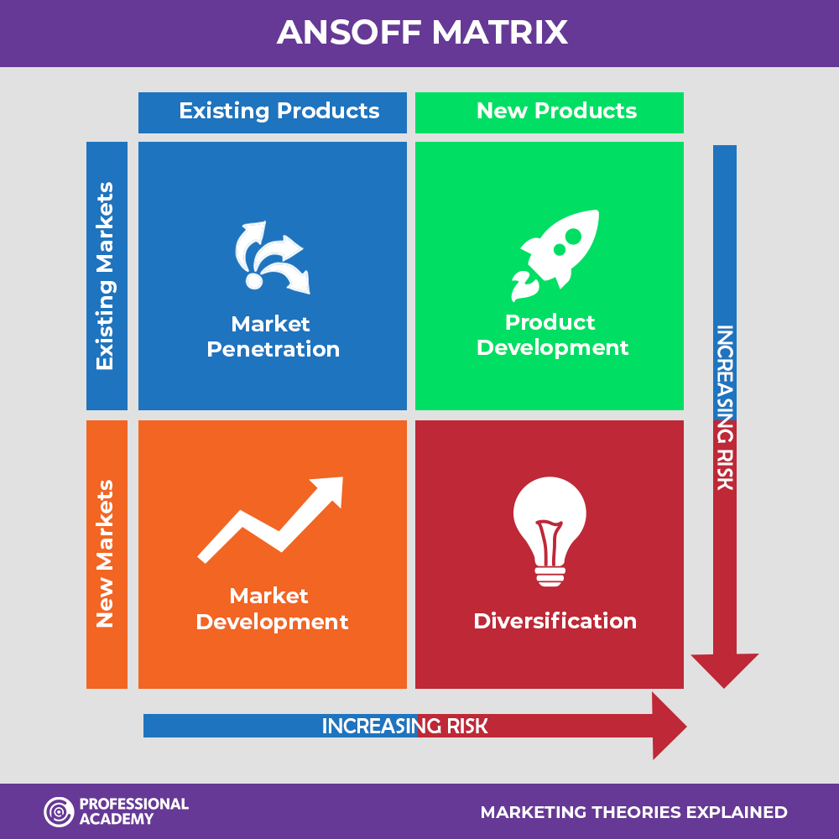

Framework
Work through each area and identify potential income opportunities for your organisation.
- Market Penetration (existing activities, existing audience)
Increasing income from what you already do. Examples:
- Improving donor retention
- Increasing participation in existing activities
- Encouraging repeat bookings or memberships

- Product Development (new activities, existing audience)
Creating new offers for your current community. Examples:
- Paid workshops or training sessions
- New community services or events
- Skill-sharing or repair sessions

- Market Development (existing activities, new audiences)
Expanding reach to new groups or partners. Examples:
- Corporate partnerships
- Schools or education programmes
- Expanding into neighbouring communities

- Diversification (new activities, new audiences)
Developing entirely new income streams. Examples:
- Eco-tourism activities
- Consultancy or advisory services
- Trading arms or social enterprises
- Product sales linked to environmental work

Discussion Prompts
- Which options best align with our mission and values?
- What capacity and skills do we currently have?
- What level of risk are we comfortable with as a group?
- Which ideas feel realistic in the short, medium, and long term?
- Where could partnerships help reduce risk or increase success?

Output
By the end of the exercise, you should have:
- A shortlist of potential income ideas across the four categories
- A clearer understanding of risk levels for each option
- An initial view of which strategies are most realistic and aligned
- A foundation for prioritising next steps in income diversification

Key insight
Not all income opportunities carry the same level of risk. The Ansoff Matrix helps groups balance safe improvements to existing income with more innovative but higher-risk ideas, ensuring diversification is both strategic and realistic.

Developing and testing income ideas

Offer Canvas

Purpose
To turn an early idea into a clear, structured income offer that your group can understand, test and develop. It helps move from vague ideas to something practical and deliverable.
This is an adaptation of wider business modelling tools such as the Business Model Canvas developed by Alexander Osterwalder and the Lean Canvas developed by Ash Maurya. It is simplified here for use by community groups exploring income diversification.
It is sometimes also referred to as a Value Proposition Canvas or Service Canvas, depending on the context.
When to use it
- When developing a new service, activity or product
- When exploring new income ideas
- When comparing different options
- Before testing or piloting an idea
How to use it
Work through the questions as a group:
- Choose one idea to focus on
- Go through each section step by step
- Keep answers simple and specific
- Avoid vague or general statements
- Agree a clear final version of the offer

Offer Canvas Questions
What are we offering? | - What exactly is the product, service or activity?  - What does it include?
Who is it for? | - Who is the main audience or user?  - Be specific (avoid “everyone”)
What need or problem does it address? | - What issue are we solving?  - Why does it matter?
Why would people choose this? | - What makes it useful or different?  - What benefit does it provide?
How will we deliver it? | - What do we need (people, time, skills, space, equipment)?  - How will it work in practice?
How will it generate income? | - Will it be paid for, membership-based, donation-based or contracted?  - What is the basic income or pricing model?

Key prompts
- Can we explain this clearly in one or two sentences?
- Would someone understand what they are paying for or joining?
- Does this align with our mission and values?
- Do we have the capacity to deliver it well?

Output
By the end of this exercise you should have:
- A clear description of your offer
- A defined target audience
- A basic income model
- A starting point for testing or piloting

Key insight
If an idea cannot be clearly explained, it is not ready yet. A strong offer is simple, specific and easy for others to understand and engage with.

Pricing for Purpose

Purpose
To help your group set prices for services, activities or products in a way that is fair, realistic and sustainable. This tool supports decision-making by balancing financial viability with social and environmental aims.
It is based on the Triple Bottom Line approach developed by John Elkington, which encourages organisations to consider people, planet and profit equally when making decisions.
Elkington’s approach highlights that long-term success should not only be measured financially, but also by social and environmental impact.
When to use it
- When developing a new income-generating offer
- When setting or reviewing prices
- When testing whether an idea is financially viable
- When balancing accessibility with sustainability
How to use it
Work through the three perspectives as a group:
- Estimate the real cost of delivering your activity
- Research what similar organisations, charities, or social enterprises are charging for comparable services (use this as a baseline, not a fixed rule)
- Discuss what is fair and accessible for your community
- Consider what level of income is needed for long-term sustainability
- Agree a pricing approach that balances all three
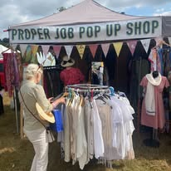

People, Planet, Profit Framework
People (social value) | - Is the price accessible to the community?  - Could anyone be excluded?  - Does this support fairness, inclusion, and participation?
Planet (environmental value) | - Does this support environmentally responsible delivery?  - Are we covering the real cost of sustainable practice?
Profit (financial sustainability) | - Does the price cover costs?  - Does it allow reinvestment into the organisation?  - Does it support long-term stability and resilience?

Making pricing more accessible
To ensure inclusivity, groups may use different approaches depending on context:
- Sliding scale pricing (different prices depending on ability to pay)
- Pay what you feel / pay what you can models
- Sponsorship or subsidised places (higher contributions help support access for others)
- Blended funding models (grant funding used to reduce costs or support access for communities in need)
These approaches can help reduce financial barriers while maintaining sustainability.

Key prompts
- What does it actually cost us to deliver this?
- What are similar organisations or groups charging for this type of service?
- Are we broadly in line with local or sector “going rates”?
- What is a fair price for the people we want to reach?
- What do we need to remain financially sustainable?
- Are we relying too heavily on unpaid or voluntary input?
- Could grants or sponsorship help make this more accessible?
- Does this pricing model reflect our values as well as our costs?

Output
By the end of this exercise, you should have:
- A clear understanding of real delivery costs
- A realistic, evidence-informed pricing approach
- A balance between accessibility and sustainability
- A model that supports long-term resilience

Key insight
As the Triple Bottom Line approach highlights, organisations must balance people, planet and profit. Pricing is not just a financial decision—it determines both accessibility and long-term viability.
Without generating sufficient surplus or reinvestable income, environmental initiatives often struggle to sustain impact over time. A strong pricing approach ensures that fairness and financial sustainability work together, supported by real-world understanding of what others in the sector are charging.

Pilot Planning Canvas

Purpose
To test an income idea at small scale before committing significant time, money, or resources. It helps groups learn what works in practice, identify risks early, and refine an offer before scaling.
This tool is informed by two widely used approaches:
- The Minimum Viable Product (MVP) concept from The Lean Startup by Eric Ries, which focuses on testing the smallest possible version of an idea to learn quickly with minimal risk
- The Theory of Change approach commonly used in the charity and community sector to clarify what you are trying to achieve and how your activities lead to outcomes
Together, these approaches help groups both test ideas in practice and stay clear about the change they are trying to create.
When to use it: | - After developing a clear offer  - Before investing heavily in a new income idea  - When testing demand or feasibility  - When you need real-world feedback quickly
How to use it: | Work through the questions as a group:  - Define the smallest possible version of your idea (MVP approach)  - Identify what you are trying to achieve and why (Theory of Change thinking)  - Plan a simple, low-risk pilot  - Estimate basic costs and any potential income  - Deliver the pilot at small scale  - Gather feedback and reflect on what happened  - Decide whether to adapt, continue, or stop

Key ideas behind the tool
Minimum Viable Product (MVP)
Start with the simplest version of your idea that still allows you to learn what works in real life. Focus on learning, not perfection.
Theory of Change (simplified)
Be clear about:
- What you want to achieve
- What activities you will deliver
- What change you expect to see

Output
By the end of this exercise you should have:
- A small-scale version of your idea ready to test
- A clearer understanding of your intended outcomes
- A basic pilot plan and budget
- Real-world feedback to inform next steps

Key insight
Good pilots are both practical and purposeful. The MVP approach helps you test quickly and cheaply, while Theory of Change ensures you stay focused on the impact you want to create.
TOP TIPS

Not all good ideas are worth doing right now

Impact vs Effort Matrix

Purpose
To help your group prioritise income ideas and activities by comparing the potential impact against the effort required to deliver them. This supports better decision-making by focusing time and resources on the most effective opportunities.
This tool is widely used in planning and innovation work to quickly assess what is worth doing first, what can be developed later, and what may not be worth pursuing.

Framework
Plot your ideas on a simple 2x2 grid:
Impact = How much benefit or value the idea could create (income, engagement, environmental or social impact)
Effort = How much time, money, skills, or resources are needed to deliver it

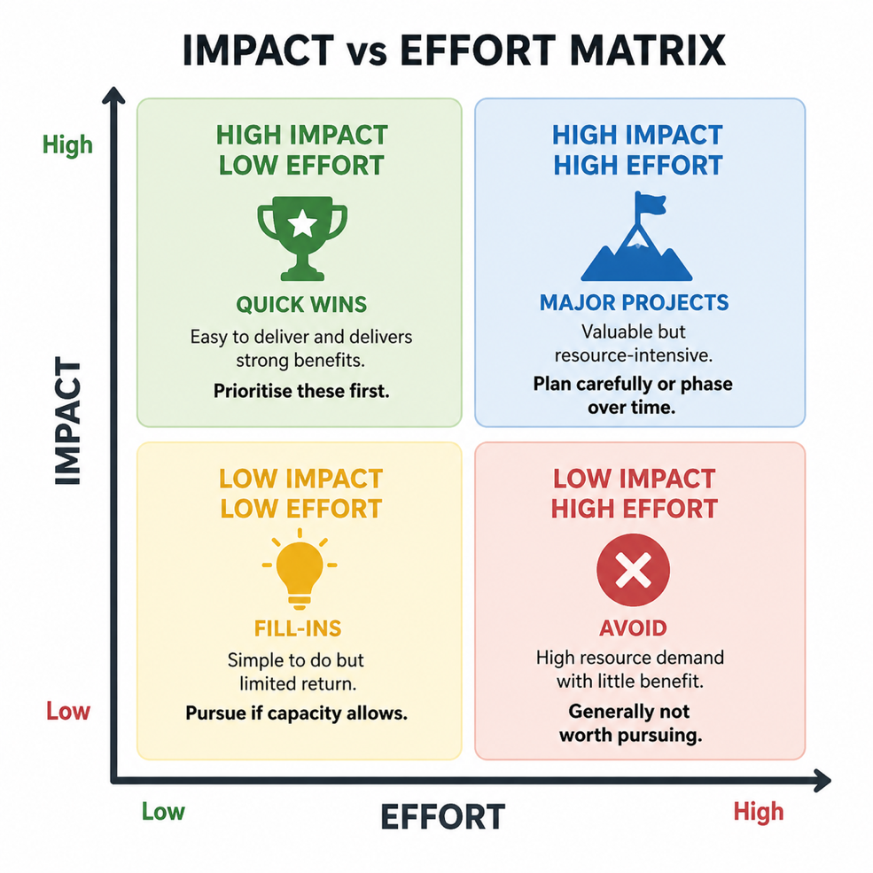

How to use it
- List your income ideas from other tools (Offer Canvas, SWOT, Ansoff Matrix)
- Discuss as a group and place each idea on the matrix
- Be honest about effort required (don’t underestimate it)
- Focus on realistic delivery capacity, not ideal scenarios
- Agree priorities based on the positioning

Key prompts
- What will make the biggest difference for the least effort?
- Which ideas are too resource-heavy for our current capacity?
- Which opportunities align strongly with our mission and income goals?
- What can we realistically deliver in the next 3–6 months?

Output
By the end of this exercise you should have:
- A prioritised list of income or project ideas
- Clear “quick wins” to focus on first
- Identification of longer-term development projects
- A clearer sense of capacity and realistic workload

Key insight
Not all good ideas are worth doing right now. The Impact vs Effort Matrix helps groups focus on what will create the most value with the resources they actually have, improving both efficiency and long-term success.

Financial planning for sustainability
Strong financial planning is essential for turning ideas into sustainable, deliverable activities. This section introduces an integrated approach that brings together community insight, income generation, activity planning, and budgeting into one clear and practical process.
The Integrated Financial Planning, Budgeting & Sustainability Tool helps organisations move beyond isolated budgeting and instead develop a joined-up system where financial decisions are directly informed by real community need, strategic priorities, and tested income assumptions.
Rather than treating budgeting as a separate task, this approach ensures that every activity is properly costed, every income stream is realistic, and every decision is grounded in financial viability.

Integrated Financial Planning, Budgeting & Sustainability Tool

Purpose
To bring together community insight, income diversification planning, activity design, budgeting, and financial viability testing into one practical framework. This tool ensures your financial planning is realistic, evidence-based, and directly linked to your organisation’s mission and delivery plans.
It helps you design services and activities that are not only needed by your community, but also financially sustainable over time.
Why this matters
This tool ensures that:
- Community insight directly shapes what you deliver
- Income generation is planned and realistic
- Activities are fully costed before delivery
- Financial viability is tested before committing resources
- Budgets reflect real-world delivery and demand
- You can adapt quickly to financial or external changes
- You are well prepared for funding applications and reporting

Step 1: Bring together your planning evidence
Use all existing insight to inform financial planning:
- Stakeholder mapping (who is involved or affected)
- Community survey findings (needs, demand, and preferences)
- Visioning outcomes (direction, values, and priorities)
- Income diversification ideas (potential revenue streams)
This ensures your financial plan reflects real needs and strategic direction.

Step 2: Design and test activity viability
Before building the budget, test whether each planned activity is financially viable.
For each activity:
Identify full costs | Include:  - Staff time (delivery and preparation)  - Materials and resources  - Venue and equipment  - Transport and delivery costs  - Overheads and administration  - Hidden or indirect costs
Calculate total cost of delivery | Combine all costs to establish the true full cost of the activity.
Set income assumptions | Estimate realistic income sources:  - Grants or contracts  - Fees or sales  - Donations or sponsorship  - Cross-subsidy from other activities
Establish break-even point | Determine the minimum income required to cover costs.
Test scenarios | - Best case  - Realistic case  - Worst case  This helps you understand risk and resilience before delivery begins.

Step 3: Build your activity-based budget
Once viability is confirmed, develop your budget:
- Base costs on viability testing
- Link income directly to specific activities
- Ensure all planned work is fully costed
- Map income and expenditure across the year
This creates a clear link between what you plan to do and what it will cost.

Step 4: Map income across the year
Develop a financial timeline showing:
- When income will be received
- When activities will be delivered
- Seasonal funding patterns or peaks
- Pressure points or cash flow gaps
This helps you plan ahead and avoid financial risk.

Step 5: Agree the budget as a group
The budget should be collectively reviewed and agreed to ensure:
- Shared ownership and accountability
- Transparency in decision-making
- Alignment with organisational priorities
- Commitment to delivery targets

Step 6: Use tools and systems to manage finances
You can use:
- Spreadsheets (Excel or Google Sheets)
- Budget templates from funders or sector bodies
- Accounting software such as Xero or Sage Accounting
Choose systems that support regular updates and clear reporting.

Step 7: Monitor, review, and adapt
Financial planning should be ongoing:
- Monthly: track income and expenditure against budget
- Quarterly: review performance and adjust strategy
Update forecasts when:
- Income changes
- Costs increase or decrease
- New opportunities arise
- External conditions shift

Step 8: Use your budget strategically
A strong integrated budget supports:
- Grant funding applications (clear cost breakdowns and timelines)
- Financial reporting and accountability
- Decision-making about services and activities
- Long-term sustainability planning

Outputs
By the end of this process, you should have:
- A fully costed, activity-based budget
- A tested understanding of financial viability for each activity
- A clear income and delivery plan across the year
- A shared and agreed financial strategy
- A system for ongoing monitoring and adaptation

Key insight
This tool ensures that financial planning is not separate from delivery or community insight. Instead, it integrates all elements into one cycle of planning, testing, budgeting, and review—supporting stronger
